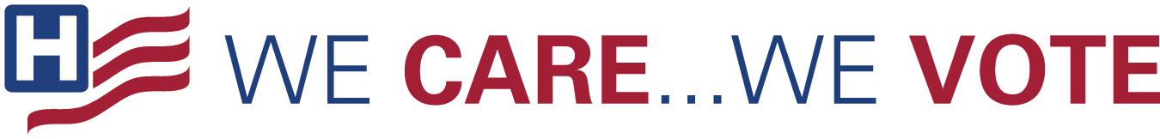

Hospital

- Health care continues to be a key priority, and it is important that our voices are heard in the 2022 midterm election. Make sure you’re registered to vote! #WeCareWeVote wecarewevote.aha.org
- The 2022 midterm elections are important to the post-pandemic landscape for hospitals and the workforce. YOU can make sure health care workers voices are heard! Get registered. #WeCareWeVote wecarewevote.aha.org
- Make sure you’re registered to vote in the 2022 midterm election. Your vote is your voice. #WeCareWeVote Vote.gov
- We encourage all employees to register to vote and make their voices heard. Check your voter registration, who is on the ballot, and how to get involved. #WeCareWeVote ballotready.org
- This will be a critical election year for the post-pandemic future for all hospitals, and the candidates we elect will make important decisions concerning health care’s future — and, ultimately, the future of our hospital. #WeCareWeVote wecarewevote.aha.org

General Messages

- Exercise your civic duty and support hospitals for a post-pandemic future. Register and plan when you will vote. #WeCareWeVote wecarewevote.aha.org
- Your vote matters – make sure your voice is heard: register to vote in the 2022 midterm election. #wecarewevote wecarewevote.aha.org
- It’s your right to help elect lawmakers and leaders who reflect your values. Register now, and make sure your voice is heard. #wecarewevote wecarewevote.aha.org
- Are you registered to vote? Check your state’s registration deadline and make sure you’re prepared to make your voice heard. #wecarewevote ballotready.org
- Do you know where your polling place is? Do you know when your state’s registration deadline is? Do you know who is on your voting ballot? The 2022 midterm election day is coming soon, make sure you’re ready to make your voice heard. #wecarewevote wecarewevote.aha.org
- Make sure you’re registered vote and committed to making your voice heard in the 2022 midterm election. wecarewevote.aha.org #wecarewevote
- Make sure you’re familiar with your state’s rules on voting and your local poll opening and closing times. Visit vote.gov for more. And don’t forget to vote! #wecarewevote

Graphics

