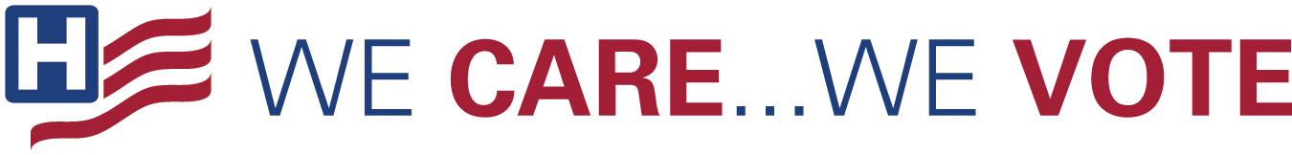
Digital Toolkit

Messages

Hospital

- Now more than ever, health care is a key priority, and it is important that our voices are heard in the 2020 election. Make sure you’re registered to vote! www.wecarewevote.aha.org
- The 2020 elections are important, and YOU can make sure health care employee’ voices are heard! Get registered. www.wecarewevote.aha.org #WeCareWeVote
- Make sure you’re registered to vote and let your voice be heard! http://voter.org/ #WeCareWeVote
- We encourage all of our employees to register to vote and make their voices heard on Election Day. Find more information at www.wecarewevote.aha.org #WeCareWeVote
- This will be a critical election year, and the candidates we elect will make important decisions concerning health care’s future — and, ultimately, the future of our #hospital. www.wecarewevote.aha.org #WeCareWeVote

General Messages

- Exercise your civic duty - register to vote. www.wecarewevote.aha.org #WeCareWeVote
- Your vote matters – make sure your voice is heard: register now. #wecarewevote www.wecarewevote.aha.org
- It’s your right to help elect lawmakers and leaders who reflect your values. Register now, and make sure your voice is heard. www.wecarewevote.aha.org #wecarewevote
- Are you registered to vote? Check your state’s registration deadline and make sure you’re prepared to make your voice heard. www.wecarewevote.aha.org #wecarewevote
- Do you know where your polling place is? Do you know when your state’s registration deadline is? ? Election Day is coming soon, make sure you’re ready to make your voice heard. www.wecarewevote.aha.org #wecarewevote
- Make sure you’re registered vote and committed to making your voice heard in this election. www.wecarewevote.aha.org #wecarewevote
- Make sure you’re familiar with your state’s rules on voting and your local poll opening and closing times. Visit www.vote.org for more. And don’t forget to vote! #wecarewevote

Graphics

Twitter/LinkedIn

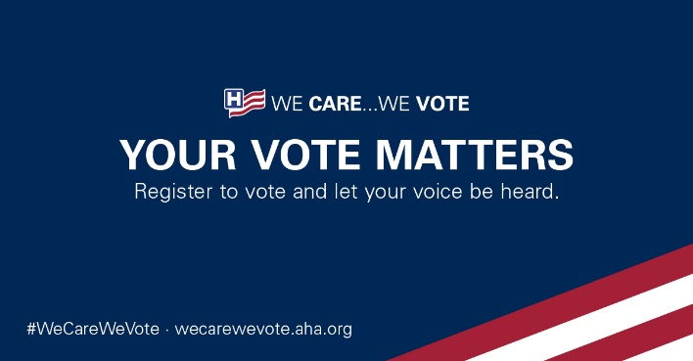
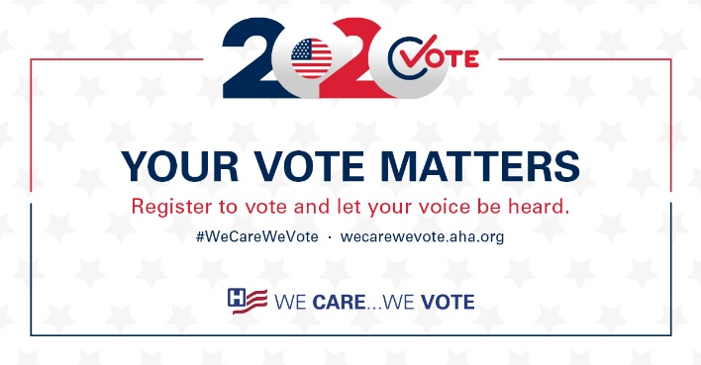
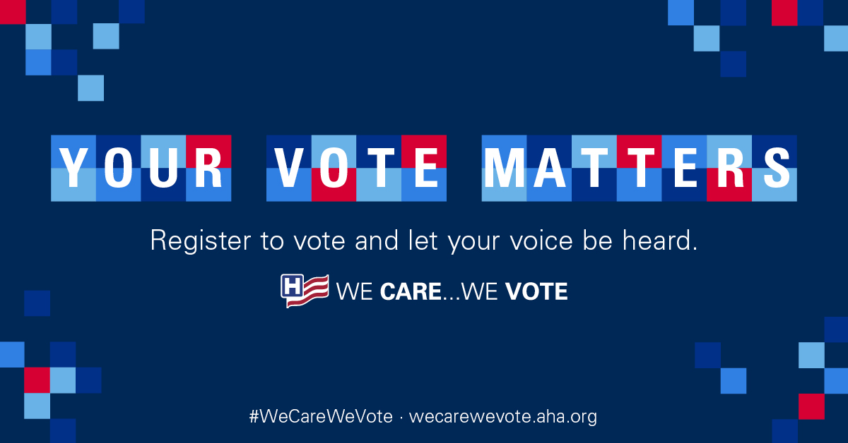

Facebook/Instagram

